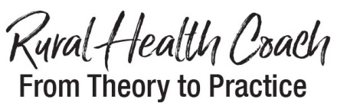

Return completed forms to Mary Jane Clark mclark@mhtlc.org by APRIL 26, 2019 or Professor Clark Mailbox in the Department of Health Sciences and Social Work in Stipes Hall 402
Rural Health Coach Project Application

Program Design Introduction
The Rural Health Coach: From Theory to Practice Program/Course is aimed directly at preparing students to meet with clients from a variety of settings in partnership with a regionally located small, rural hospital. As such, students who register for the program are expected to commit themselves to a semester of curriculum and a semester of an assigned client.

Name | Year of College
Email Address Campus  Personal Email | Major in College
Cell Phone | CPR Trained: yes or no
Emergency Contact/ Relationship | Emergency Contact/Phone Number
Vehicle Available: yes or no | Valid Driver License: yes or no
(2) References: Name and Phone Number

Please identify days and times that you are available for at least 2 hours on a regular basis. We will use the allotted time to schedule initial training and introductory visits with your assigned clients. In addition, as part of your course requirements, every week you will need to report on your client to the care coordination team.

Monday: Tuesday:
Wednesday: Thursday:
Friday: Saturday:
Sunday:__________________________________

Rural Health Coach Program Overview
From Theory to Practice Course is offered through Independent Study. The program involves a training module with assigned readings and preparation for meetings with the Coordinator. Client visits involve approximately 2-4 hours of off-campus work each week. Reliable transportation to meet with clients is a requirement for the course. There is considerable flexibility built into the program to accommodate individual schedules, but students must be able and willing to put the required time into the course. It is essential to consider in advance what other activities outside of normal classes and labs (e.g. work, sports, and volunteer activities) that you are likely to have to balance with the rural health coaching program.

Please list those activities or commitments and explain why you are confident you can achieve the necessary balance to work with client’s off-campus.

What is your motivation for taking this course?

What is your primary health coaching area of interest? What would you like to learn?

What are your interests and hobbies?

